Chapter 9, Problem 84.

The ac bridge shown in Fig. 9.84 is known as a Maxwell bridge and is used for accurate measurement of inductance and resistance of a coil in terms of a standard capacitance C_{s}. Show that when the bridge is balanced,

L_{x} = R₂ R₃ C_{s} and 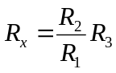

Find L_{x} and R_{x} for R₁ = 40 kΩ, R₂ = 1.6 kΩ, R₃ = 4 kΩ, and C_{s} = 0.45 μF.

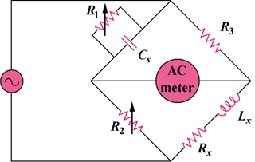

Figure 9.84
For Prob. 9.84.

